Index.html test

Test 1 | 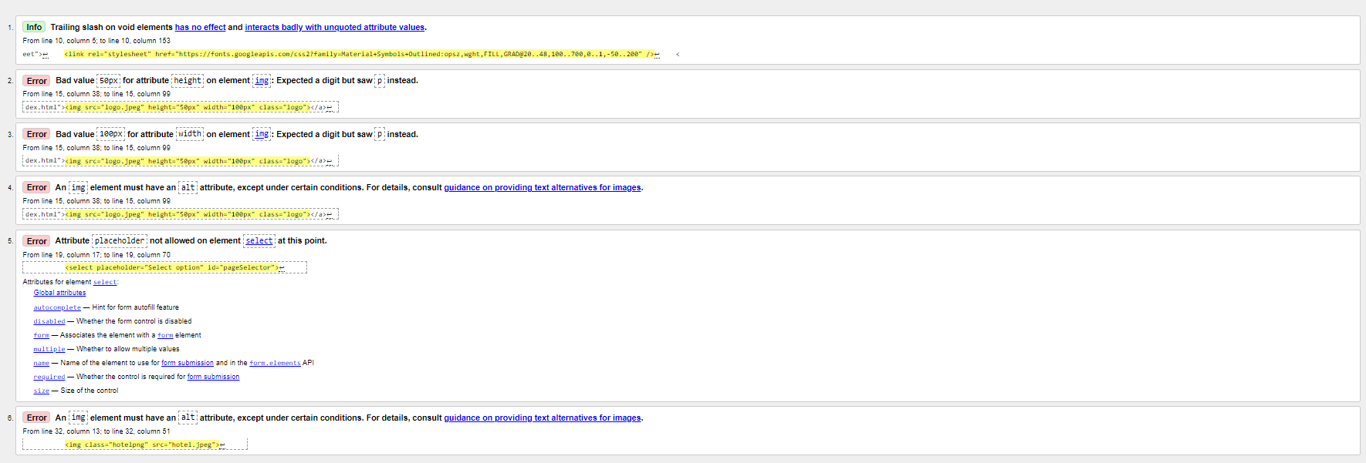
Test 2 | 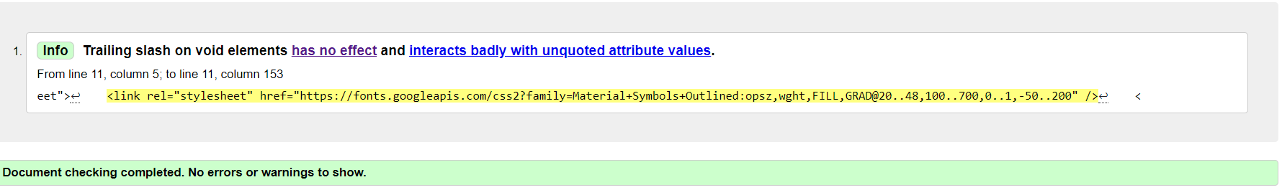
Test 3 | 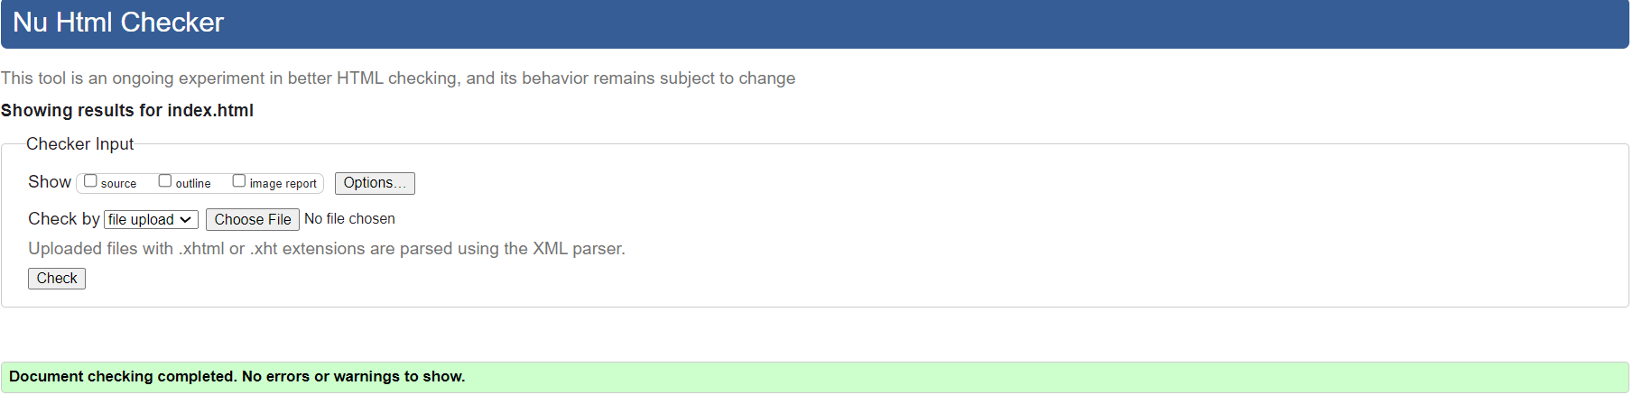

add.html test
Test 1 | 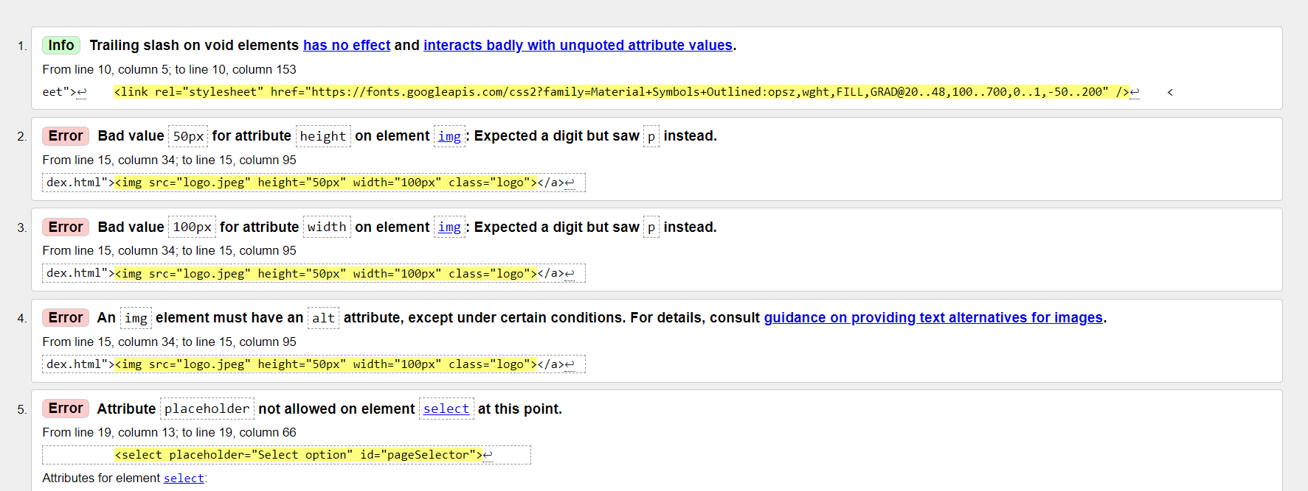
Test 2 | 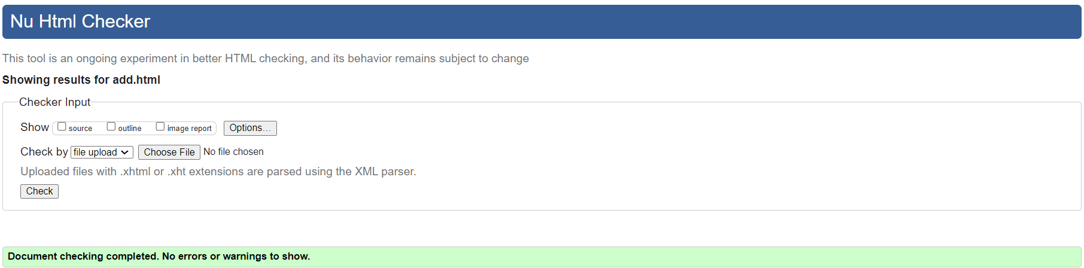

Gallery.html test

Test 1 | 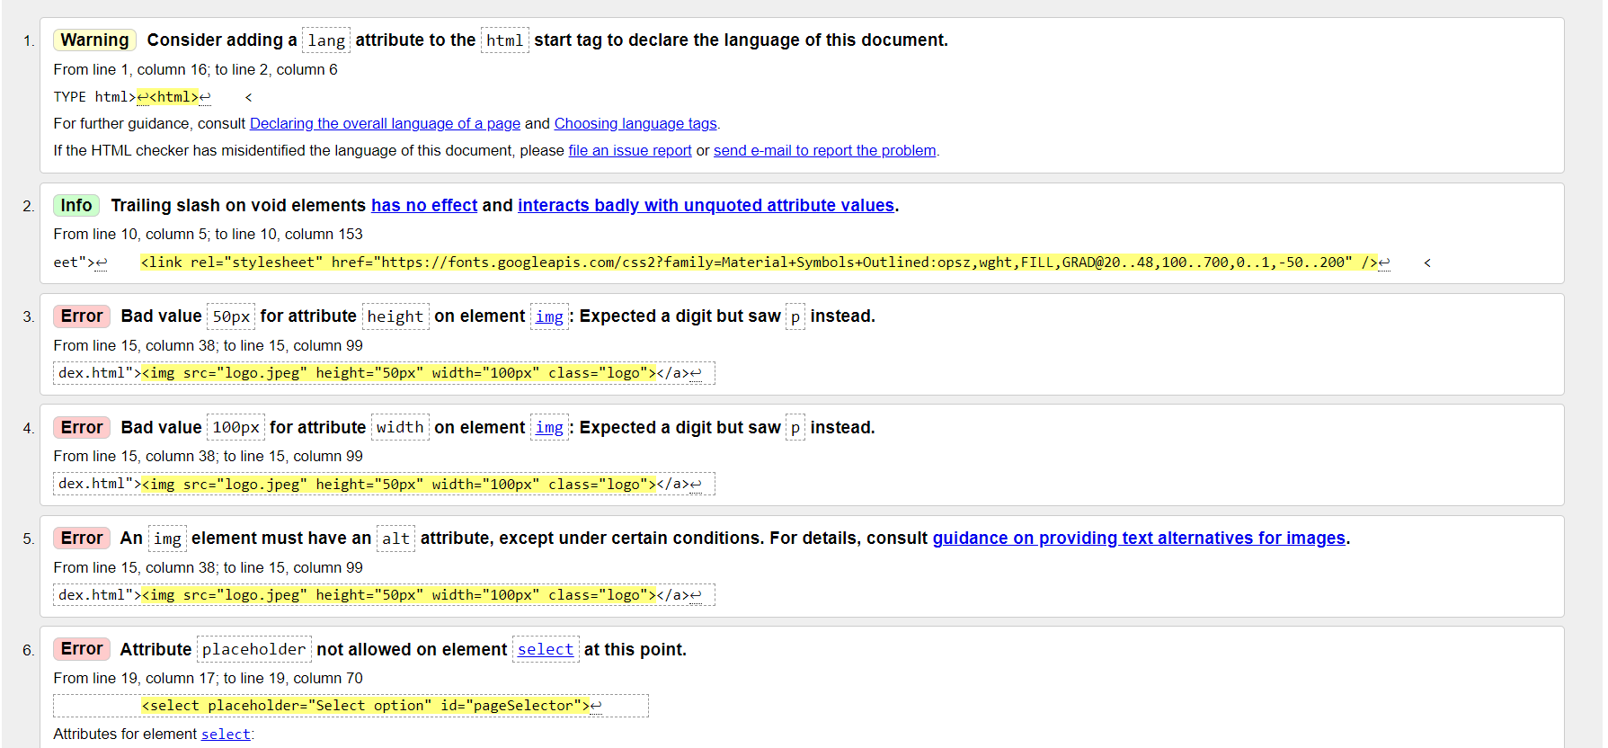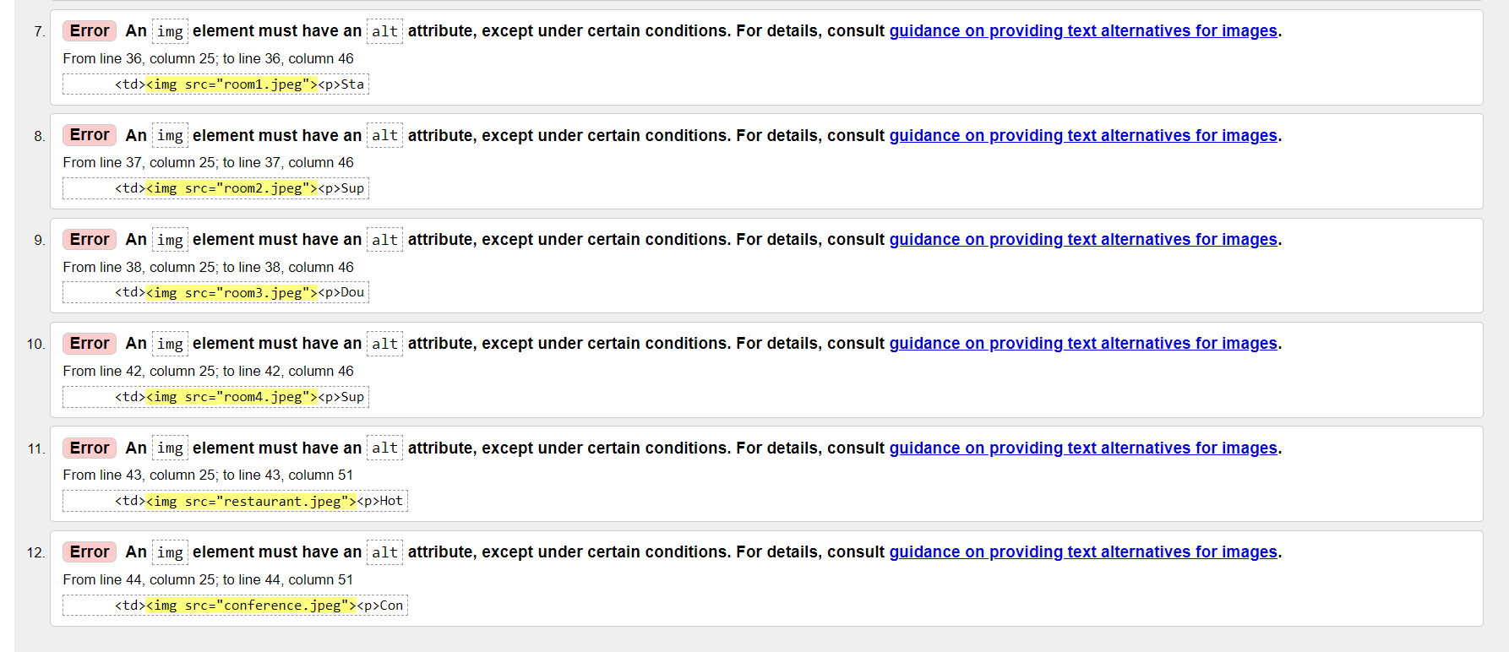
Test 2 | 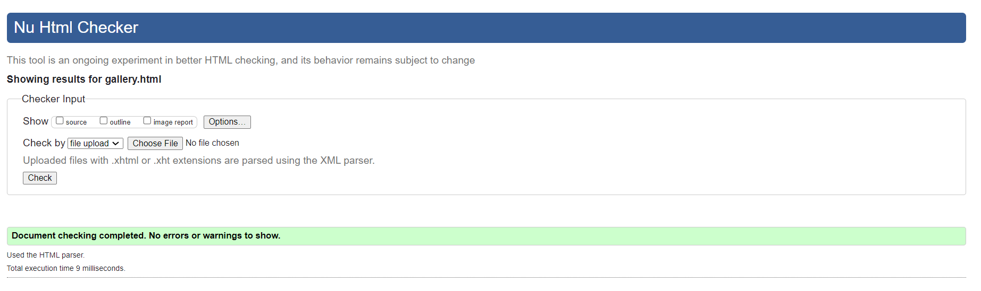

Facilities.html test

Test 1 | 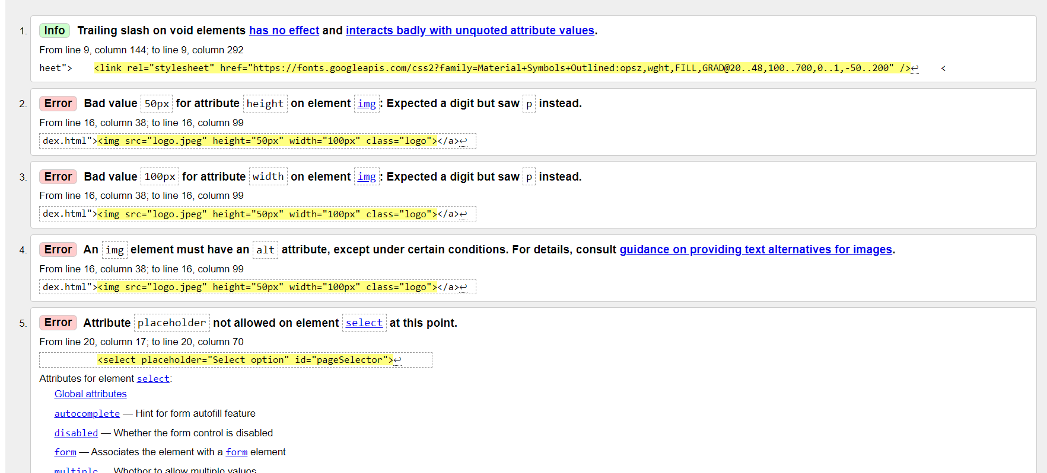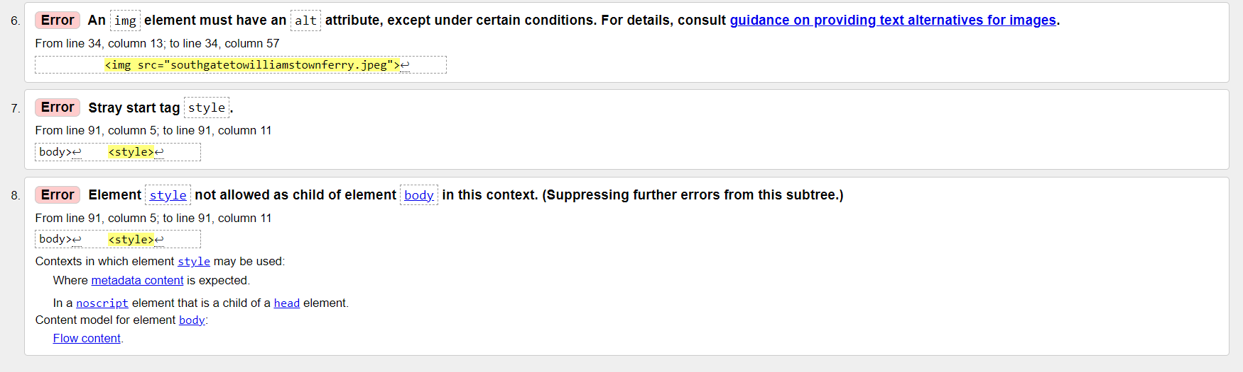
Test 2 | 